1.VM Related Issue:

If you face any VM related issues, then please follow below solution in primary level.

Below is some common issue’s screen shot & their solution:

**Problem: VM reconnecting issue/Not able to login/the User profile failed to attach/Blank screen/VM is slow/Native client login issue.**

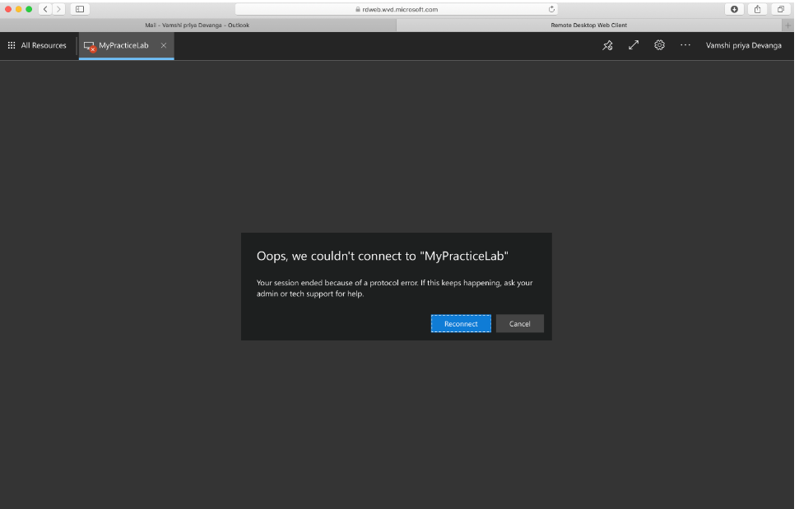

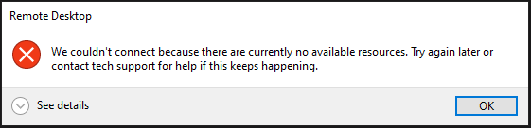

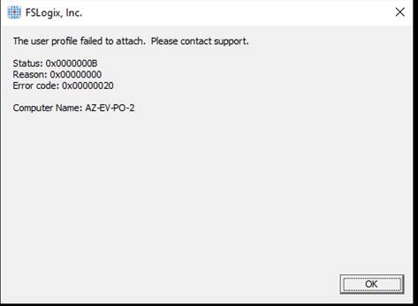

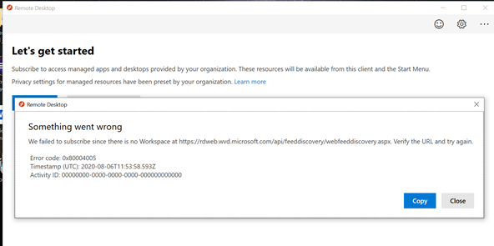

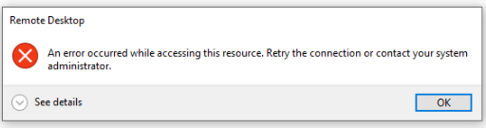

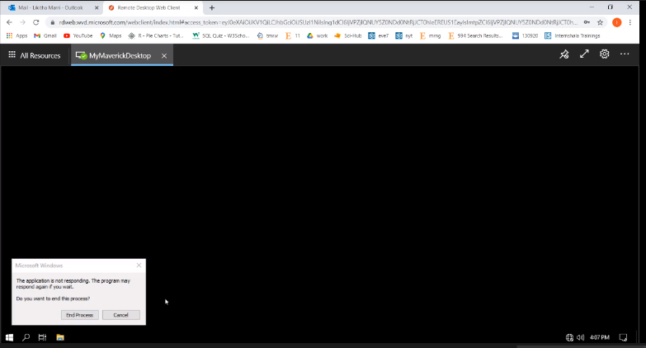

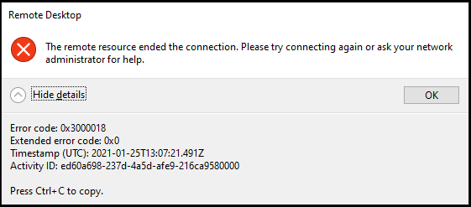

Solutions-

1. First sign out VM properly & sign in again.

2.Clear all browsers logs for your local machine, restart your base machine & try login

3. Go to remote desktop & Click on Unsubscribe & subscribe again. PFB screen shot

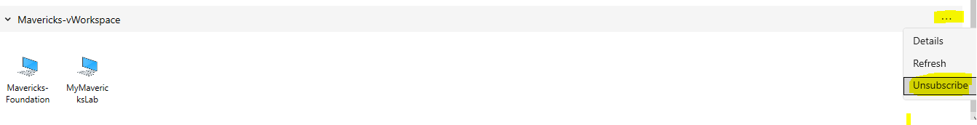

4.Use [Web browser client](https://rdweb.wvd.microsoft.com/arm/webclient/index.html) to login if native client does not work

5.After login Some time screen show blank then pls wait some interval screen will load automatically.

Note: VM require proper internet bandwidth to connect, so check your internet first if you get any VM slowness issue.

Note:

Please Sign out properly from VM once complete your Work.

Do not close VM-RDP connection directly.

Steps: Go to start menu->click on your profile name->click on Sign Out.

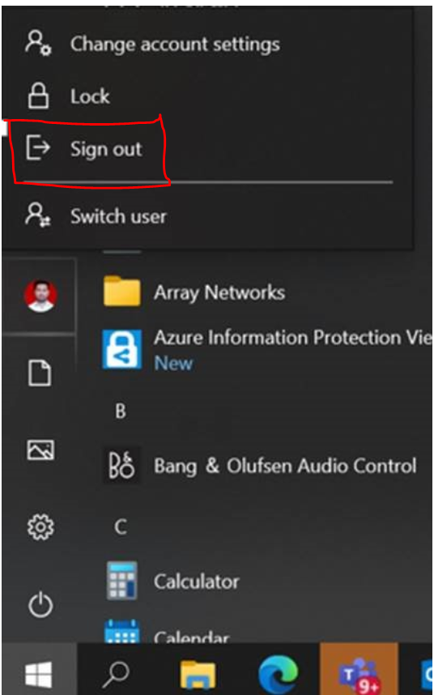

**Problems- For window/VM login password expire or account locked.**

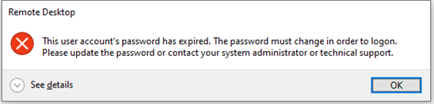

**Solution**: Please contact GSD18001024392 OR login into <https://art.hexaware.com>

**Problem-Not able to search anything from VM start menu or icon not available on desktop**

**Solution-**If you are not able to search any installed software from start menu then please access installed file from below path.

C:\ProgramData\Microsoft\Windows\Start Menu\Programs